CPEG 585 – Assignment #1

1. Create the image processing example described in the BasicImageProcessingCsharp.pdf handout

(available under the link for Video Lectures 2017) menu on the CPEG 585 web site.

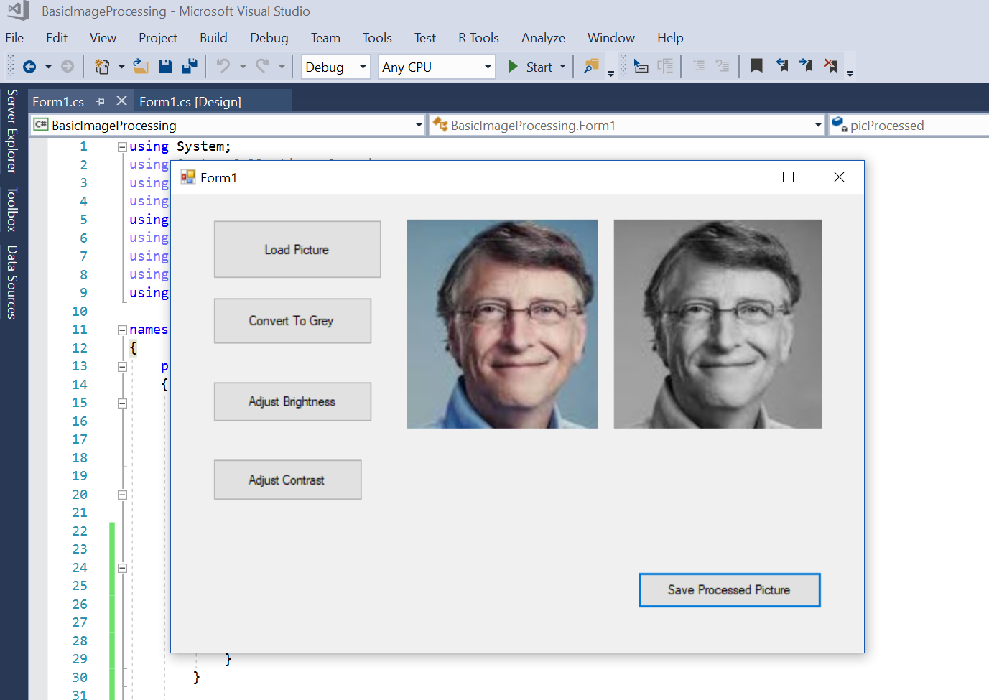

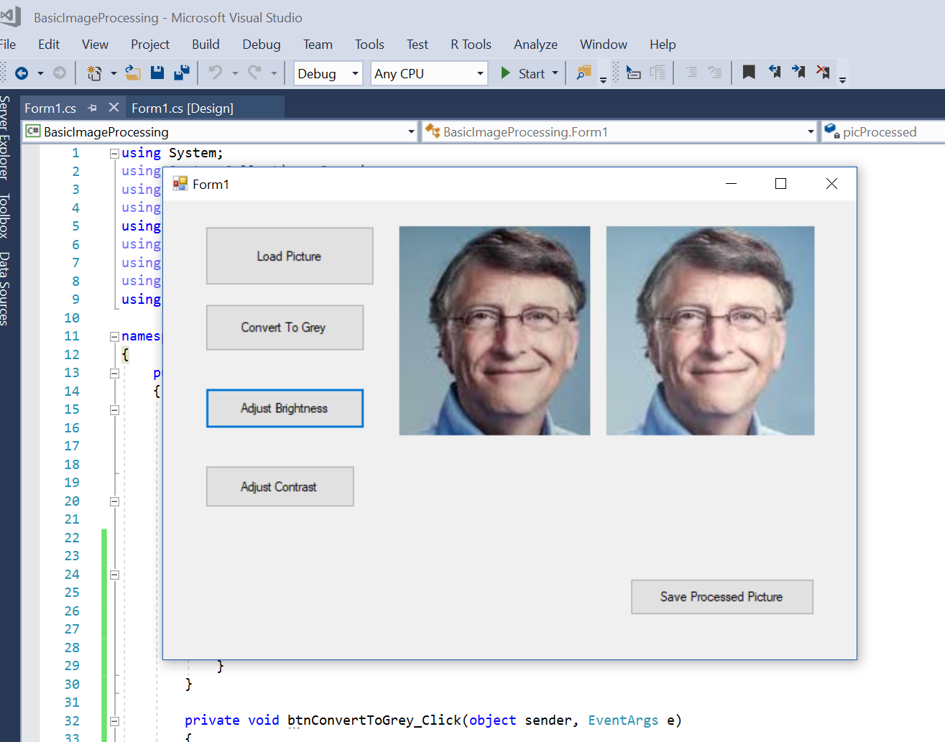

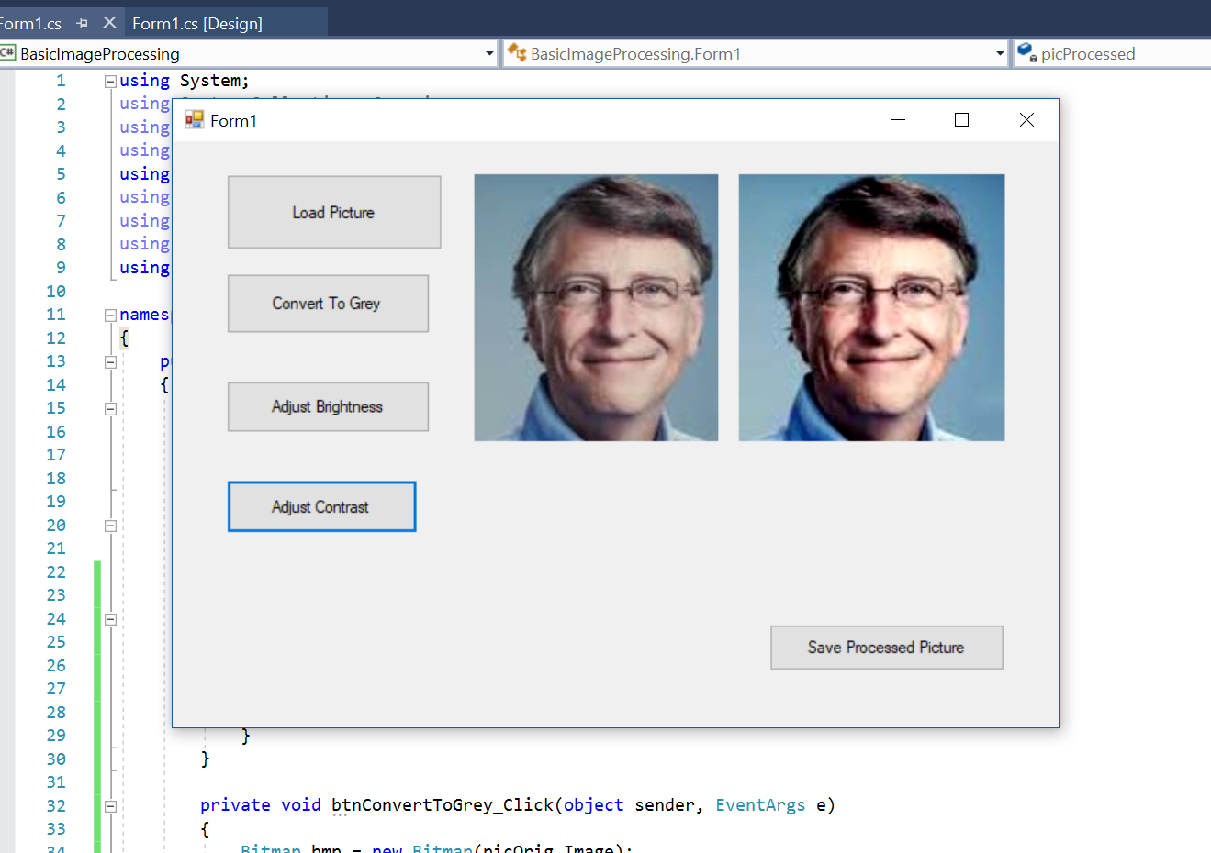

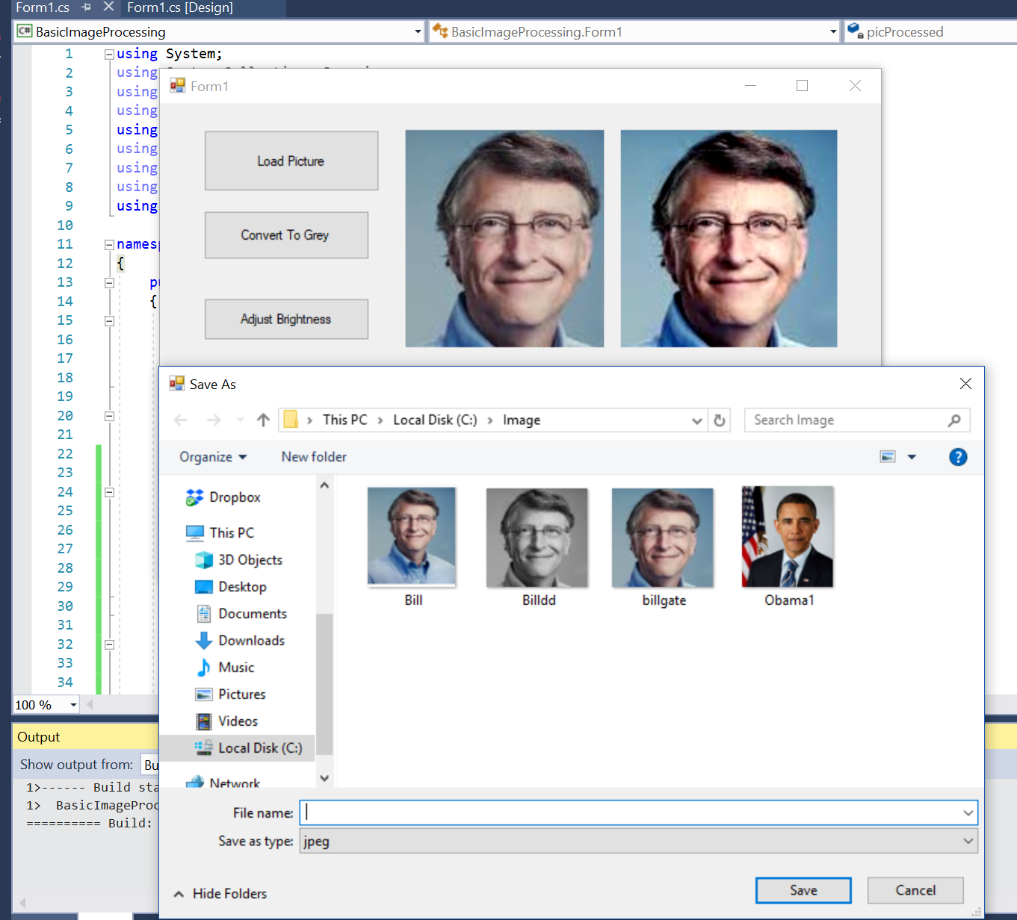

2. Implement the Python examples in the PythonTutorial_Part1.pdf (available under the link for

Video Lectures 2017) menu on the CPEG 585 web site.

